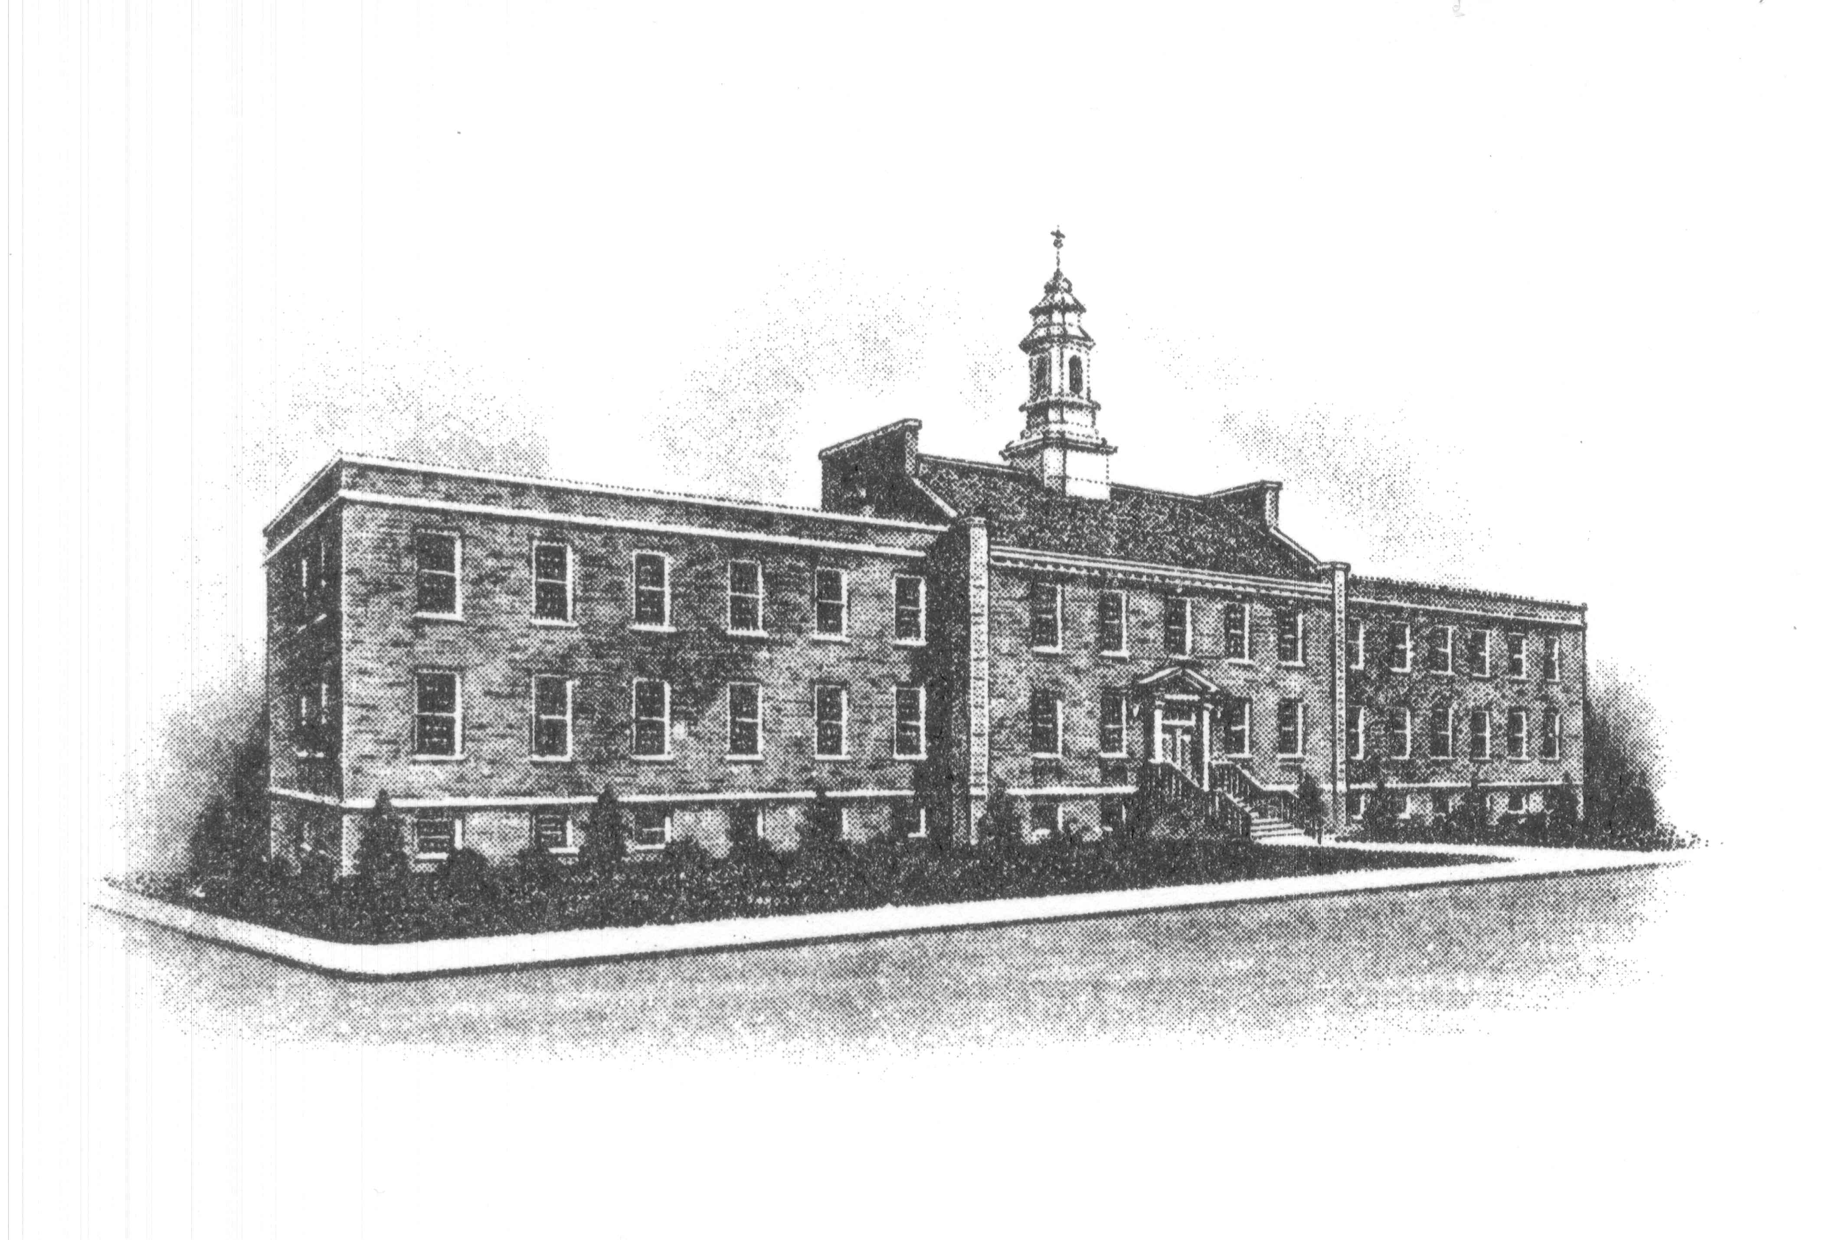
The Borough of Sayreville
Sayreville Economic & Redevelopment Agency
167 Main Street
Sayreville, NJ 08872
(732) 390-7077 - Phone

MEETING CANCELLATION

Please take notice that the Sayreville Economic & Redevelopment Agency (SERA) in the Borough of Sayreville, N.J. has cancelled its Thursday, May 27, 2021 meeting. Any matters which were to be heard and/or discussed on May 27, 2021, are hereby adjourned to Thursday, June 24, 2021 at 6:30 PM.

Thank you.

Joan M. Kemble
Secretary
Sayreville Economic & Redevelopment Agency (SERA)
732-390-7077

